**Outline Use Case (By Timothy Folds)**

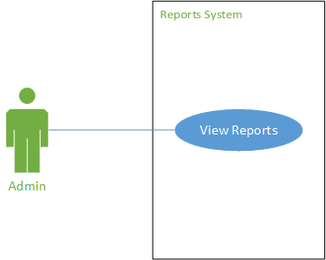  
**Admin views voting data**

**Brief Description:**

An admin views Reports

**Basic Flow:**

1. Admin requests to view reports
2. System displays reports page
3. End use case

**Alternative Flows:**

A1 - Unauthorized access

A2 - Admin views voting data

A3 - Admin views leaderboards

A4 - Admin views demographics

A5 - Admin views block voting data

A6 - Admin views genre voting data

**Sub Flow:**

S1 – Select Block

S2 – Select Genre

S3 – Select Film

S4 – Display Film Info

**Pre-conditions:**

User must be logged in as an admin.

**Scenarios:**

Admin goes to ‘Reports’ page of web application to determine winners - Basic flow

A user tries to access the reports page (via URL) without being logged in - A1

An admin clicks on “voting data” tab to view voting data - A2

An admin clicks on “leaderboards” tab to view leaderboards - A3

An admin clicks on “demographics” tab to view demographics - A4

An admin selects “block” radio button to view voting data by blocks - A5

An admin selects “genre” radio button to view voting data by genre - A6

An admin selects “overall” radio button to view voting data by overall - A7